Sharing position data to OGN (Open Glider Network) using XC_Guide and smart phone.

What is OGN –
The objective of the Open Glider Network is to create and maintain a unified tracking platform for gliders, drones and other aircraft. Focused on tracking aircraft equipped with FLARM and OGN trackers, OGN is also open for integration of other flying objects tracking data sources. At the moment you already can see beacons from PilotAware, SPOT, Garmin InReach, Skymaster, FANET (paragliders) and Spidertracks circulating through our network.
Apart from through the XC Guide app you can view OGN live data here –
http://www.glidertracker.de/

XC Guide –
XC Guide is a free app from Indy Flyer and can be downloaded through play store

XC Guide helps pilots and retrieve drivers track each other using these sources:
FlyMaster ®
Livetrack24 ®
Garmin inReach ®
SPOT ®
AirWhere
Open Glider Network (OGN)
XC Globe
XC Guide can also track you into Livetrack24, SkyLines, AirWhere, OGN and XC Globe.
The main features are:
1) A Flight Computer indicating altitude, ground speed, bearing, climb/sink rate, glide angle, wind direction, time, flight duration and distance from takeoff.
Barometric pressure can be obtained either from an internal pressure sensor or via a Bluetooth XC-Tracer ® or BlueFly vario.
2) A list of pilots, integrated with your contacts, showing their wing, where they are, their tracker type and status messages etc.
3) A live map showing other pilots, retrieve buses, airspace, way-points, thermal hot-spots, flight trails plus safety and retrieve messages.
4) Navigation tool to manage waypoints, navigate and show weather forecasts (OpenWeather®).
5) Thermal assistant.
6) Competition race tasks. Tasks are fully compatible with the new PG-Race.aero service. Camera permission is requested to scan QR codes for easy task sharing.
Audible warnings alert you to 'SOS' and 'Need Retrieve' messages, as well as airspace proximity, and XC TRACER FLARM ® collision warnings.
Flights can be logged and replayed as IGC and KML files.
IGC files from XC Guide are accepted by FAI/CIVL and verified by the online validation service. They are also accepted by XContest.
XC Guide can automatically send an email to your safety contacts when you takeoff and land.

How do I use my smart phone to send position to OGN network?
Download XC Guide to your phone.
Start App press i button
Scroll down to Open Glider Network section.
Press New ID this will create a six figure code which will allow your phone to be associated with OGN.
Press Reg, this will take you to OGN website where you can create an account or logon,
Then on this site add device – you need to select device type as OGN , ID as the six figure code for your phone, aircraft type – paraglider, CN – f32
Now save and return to App and press Verify which will confirm your phone ID is now linked to OGN.
(Note if you have other devices or run livetrack you can also register this through the App)
Now go to Settings and Live Tracking. Here you can modify OGN settings (or other devices).
To test you can see yourself change OGN mode to 2. Track continuously.
Check here to see OGN –
http://www.glidertracker.de/
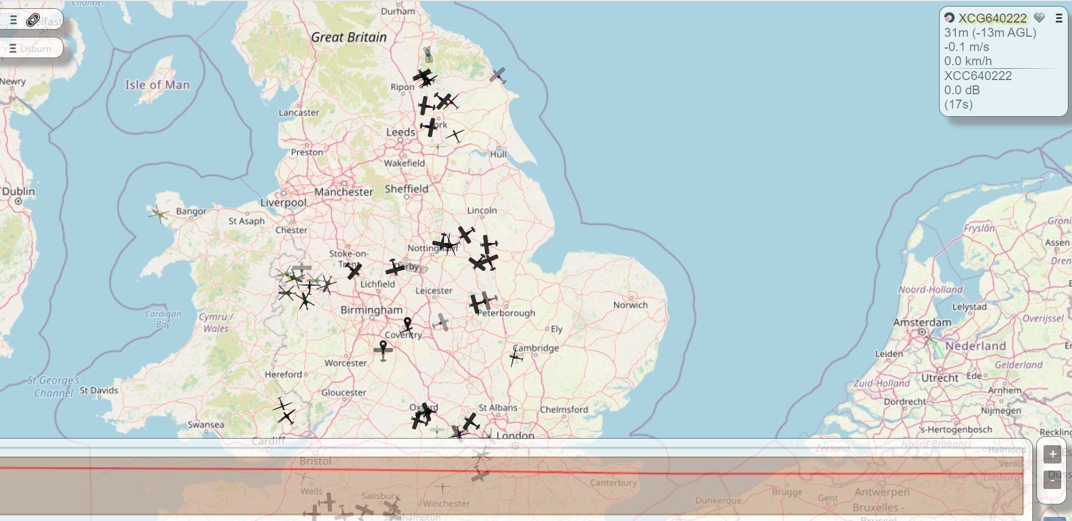

Lots of other features to play with and on your phone APP you can decide who else and from what sources you see other pilots from the various systems.

