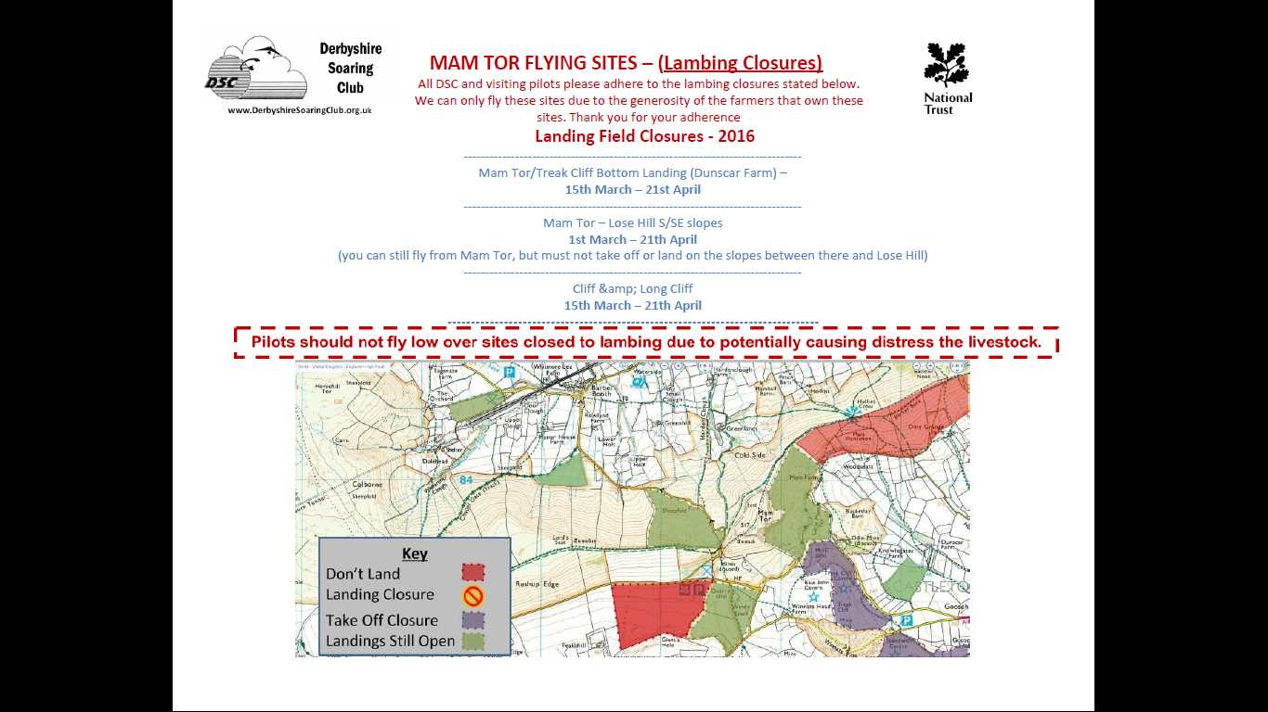
Closures -2017

Mam tor – Lose Hill S/SE slopes
1st March – 21st Apri
You can still fly from Mam but do not land or take off from the slopes beyond Hollins Cross

Mam Tor / Treak Cliff bottom landing (Dunscar Farm)
15th March – 21st April

Treak cliff and Longcliff
15th March --- 21st April

