Safety Notice
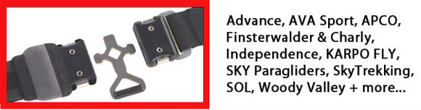
The DHV issued a safety notice for paraglider harnesses equipped with Finsterwalder CLICK-LOCK and T-LOCK buckles in the chest strap. Finsterwalder has reduced the service life to only four years! The following harness manufacturers have used the mentioned buckles in one or more of their models: Advance, AVA Sport, APCO, Finsterwalder & Charly, Independence, KARPO FLY, SKY Paragliders, SkyTrekking, SOL, Woody Valley. The buckles are also used by several other manufacturers.
Read the ADVANCE Safety Notice and their useful Quick Fix For Harnesses With Click-Lock Buckles. Ideally the affected part can be removed and sent in for free refinishing. Please supply your return address when you post it to ADVANCE France SARL Zone Industrielle F 68830 Oderen, France.
See also the WOODY VALLEY Safety Notice and their recommended fix.
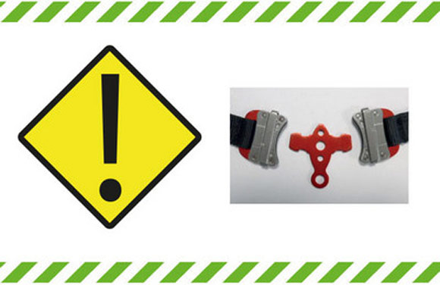
Whoops! Seems a similar problem affects many Sup'Air harnesses. They offer a free replacement Safe-T buckle which is easy to install.
It's fair to say, if you have any kind of automatic click-buckles on your harness, check them now!
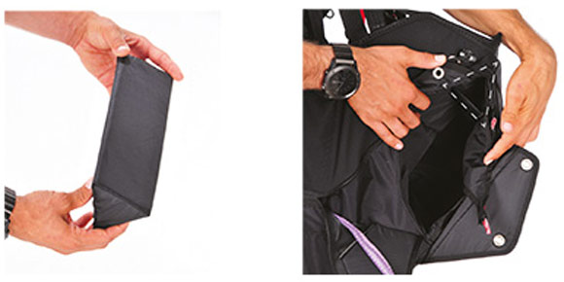
Further to Gin's previous safety notice for the Gin Gingo 3, they have issued a safety update consisting of a foam pad. All Gingo 3 owners must insert the foam pad inside the rescue container, as shown in the photos, before their next flight.
Read the full Gin Gingo Safety Update >

